**Format for uploading details in Github and Slack in word file format**

**Student Name : Shrinivasa**

**Class and Sec : VI B**

**USN : 4AL17CS092**

|  |  |  |  |  |
| --- | --- | --- | --- | --- |
| **Online Test Details** | | | | |
| **Subject** | **Operation Research** | | | |
| **Semester** | **VI - B** | | **Duration** | **45 Minutes** |
| **100%** | | **30/30** | | |

**Encl : snapshot of the test result**

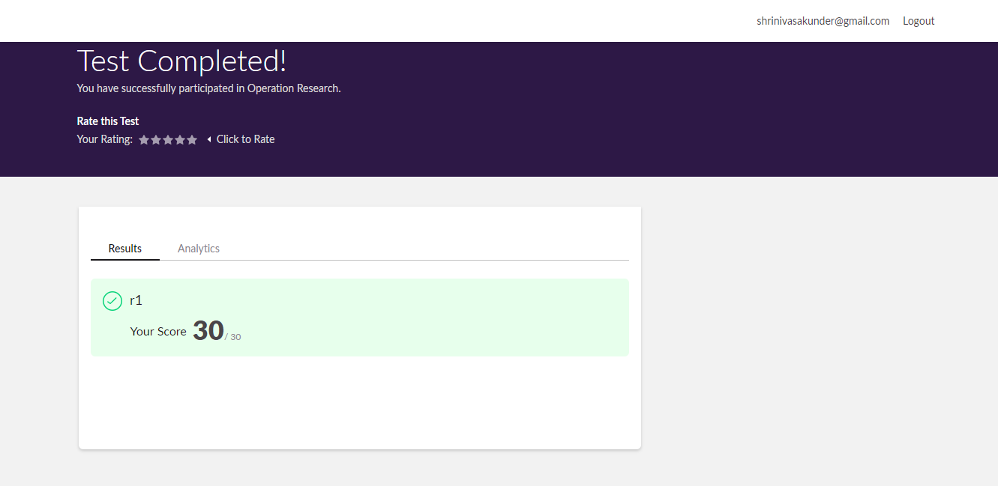

|  |  |  |  |
| --- | --- | --- | --- |
| **Certification Course Details** | | | |
| **Course** | **Blockchain Essentials** | | |
| **Certificate Provider** | **Cognitiveclass.ai** | **Duration** | **6 hours** |

**Encl : snapshots of the daily class acitivities (atleast two snap shots)**

**Progress on 29-05-2020**

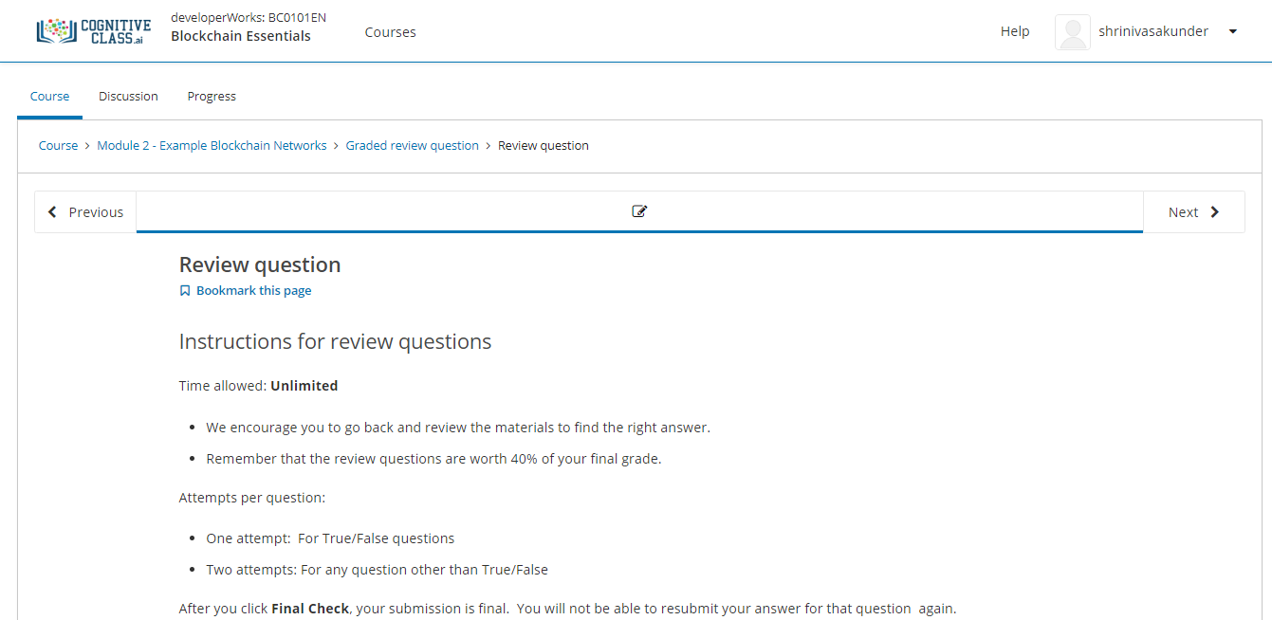

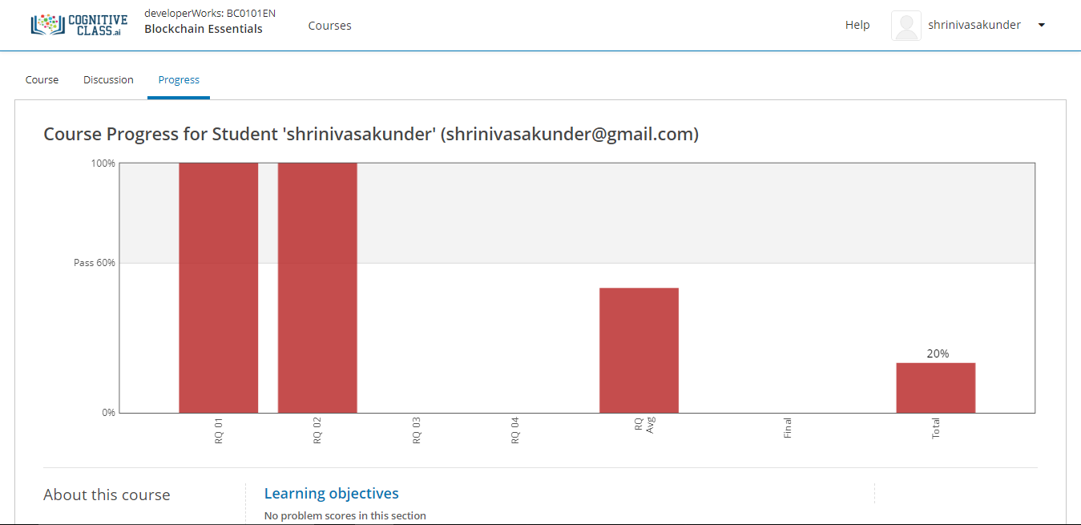

|  |  |
| --- | --- |
| **Coding Challenges** | |
| **Problem Statement:Pro1(python), Pro2(java), Pro3(c), Pro4(java), Pro5(java).** | |
| **Status: Completed** | |
| **Uploaded the report both in Github & Slack** | **Yes** |

**Encl : snapshots of your response to challenge.**

